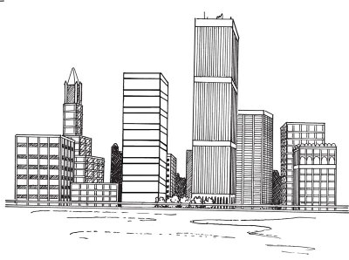

. Start With a Basic Outline

Sketch four horizontal lines below the center of the drawing area. Using a ruler, add a number of rectangles of different sizes, as shown, some overlapping others. These shapes are the front surfaces of the buildings. All vertical lines should be parallel.

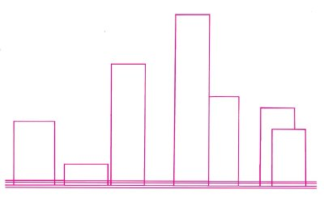

2. Add Dimension

Add a second side to each building to convey a sense of depth. Do this by drawing a vertical line shorter than the two lines for the front of the building.
Connect the side line to the front with a diagonal line. Then lay down evenly spaced horizontal lines on the front surfaces of the two buildings near the middle of the scene. Place another building in the left part of the background with a tall, narrow shape that has steps on one side.
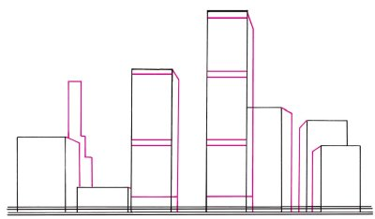

3. Add Trees and Background
Sketch five trees in front of the middle buildings using squiggly half circles around the top railing. Evenly space pairs of vertical lines on the sides of some of the buildings, as shown.
Use diagonal lines on the sides of the two tall middle buildings to continue the bands. Draw a few more buildings in the background. Give the tall narrow building on the left a second side using parallel lines connected to the front with diagonal lines. Complete the roof using two triangles.
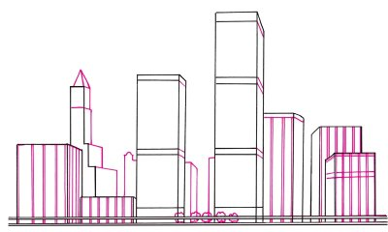

4. Add Architectural Details
Draw intersecting horizontal and vertical lines on the sides of the buildings for windows. Sketch columns on the corners of the tall building at left using vertical lines with an inverted V shape on top.

Use half circles for arches on the roof of the building at the far right. With more half circles, make the tops of the upper windows. Use dark squares for the windows of the smaller building in the middle, and form the outlines of more buildings in the distance. Draw vertical lines around the base of the tallest building.

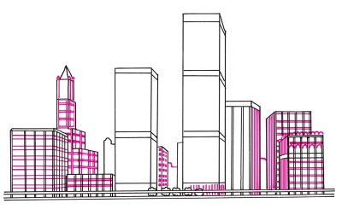

5. Finish With Shading
Thicken the lines at the bottom of the tallest building and give them rounded tops. Put vertical lines between the bands of the tallest building. Darken the buildings at the back.
Place horizontal lines on the tall buildings at the right and left of the tallest building. Shade the sides of some buildings using diagonal lines. Add short, curved lines to the trees. Sketch curving lines in the foreground to make it look like a watery surface.
You're finished ... That's quite a city!
A variety of boats are docked seaside in the next article. Learn how to draw a harbor scene.

